Title of your extended abstract

**Author 1 Name Author 2 Name Author 3 Name**

*Affiliation 1 Affiliation 2 Affiliation 3*

[*email1@xxxxx.com*](mailto:email1@xxxxx.com)[*email2@xxxxx.com*](mailto:email2@xxxxx.com)[*email3@xxxxx.com*](mailto:email3@xxxxx.com)

*(for more than three authors, repeat the above structure)*

**SUMMARY**

Replace these summary paragraphs with the text of your summary. A single-line space should be left below the title ‘SUMMARY’, and above the ‘**Key words’** below.

The summary is a short, informative abstract of no more than 300 words. References should not normally be cited in the summary. The summary should concisely state the scope and principal objectives of the research, indicate the methods used, and summarise the results and conclusions. A practical rule for writing the summary is “what we did and what we found”.

Formatting parameters used throughout most of this document are: Font, Times New Roman 9 pt; spacing: multiple at 1.05; margins: left and right 1.0cm; justified. Main headings (Level 1 headings) are centred and capitalised (Times New Roman, 10 pt, bold). Subheadings (Level 2 headings) are left justified (Times New Roman, 9 pt, bold). All full stops should be followed by two spaces.

**Key words:** 1 to 5 key words separated by commas. These will assist in cross-indexing of the article.

**INTRODUCTION**

Main headings (Level 1 headings) are centred and capitalised (Times New Roman, 10 pt, bold). To enter your introduction, highlight these paragraphs and replace with your words. The following general information is provided as a guide for new authors.

The introduction should provide sufficient background information to allow readers to understand and evaluate what follows. The introduction normally would present the nature and scope of the problem, and concisely review pertinent literature. It may include an overview of methodology, which is then detailed in later sections. The introduction generally does not include the results of the work.

**CORE SECTIONS OF DOCUMENT**

There is flexibility as to the number of sections in the core of your document, and how you name them. Make the section names as meaningful as possible, because this can help the reader’s understanding. For example, if you have a section explaining filtering methodology, a title *Wiener Filtering Methodology* is more instructive than *Method*.

Reproducibility is important in research. The methodology employed in the work must be described in sufficient detail and with sufficient references that a competent worker in the same field could duplicate the results.

Your material should be organised carefully. Include all the data necessary to support your conclusions but exclude redundant or unnecessary data. So-called *representative examples* should be truly representative.

In general, use the active voice rather than the passive. In scientific writing the word “data” is plural.

**Figures and Tables**

Subheadings (Level 2 headings) are left justified (Times New Roman, 9 pt, bold). Figures and tables should be numbered according to the order they are referenced in the paper. In the text they should be explicitly referred to by number (rather than, e.g., “the figure below”). Usage examples (in-sentence and parenthesised) for a hypothetical paper follow.

Figure 1 illustrates our phase naming conventions. The filtering process significantly attenuates reverberation energy (Figure 2). Inversion results for the three stations are given in Table 1.

**Captions**

Captions should be explicit enough to explain the figure or table without reference to the main text. Details in captions should not be restated in the text. A useful approach is that the caption simply explains what the figure is, while the significance of the figure is discussed in the main text. The removal of detailed experimental parameters from the text to the caption can improve the readability of the main text.

Captions should be placed directly beneath the relevant figure or table. The caption should be in 9 pt Times New Roman Bold font. Again spell out the word 'Figure' or ‘Table’ in full. Examples of a simple figure (Figure1), a multi-part figure (Figure 2), and a table (Table 1) follow.

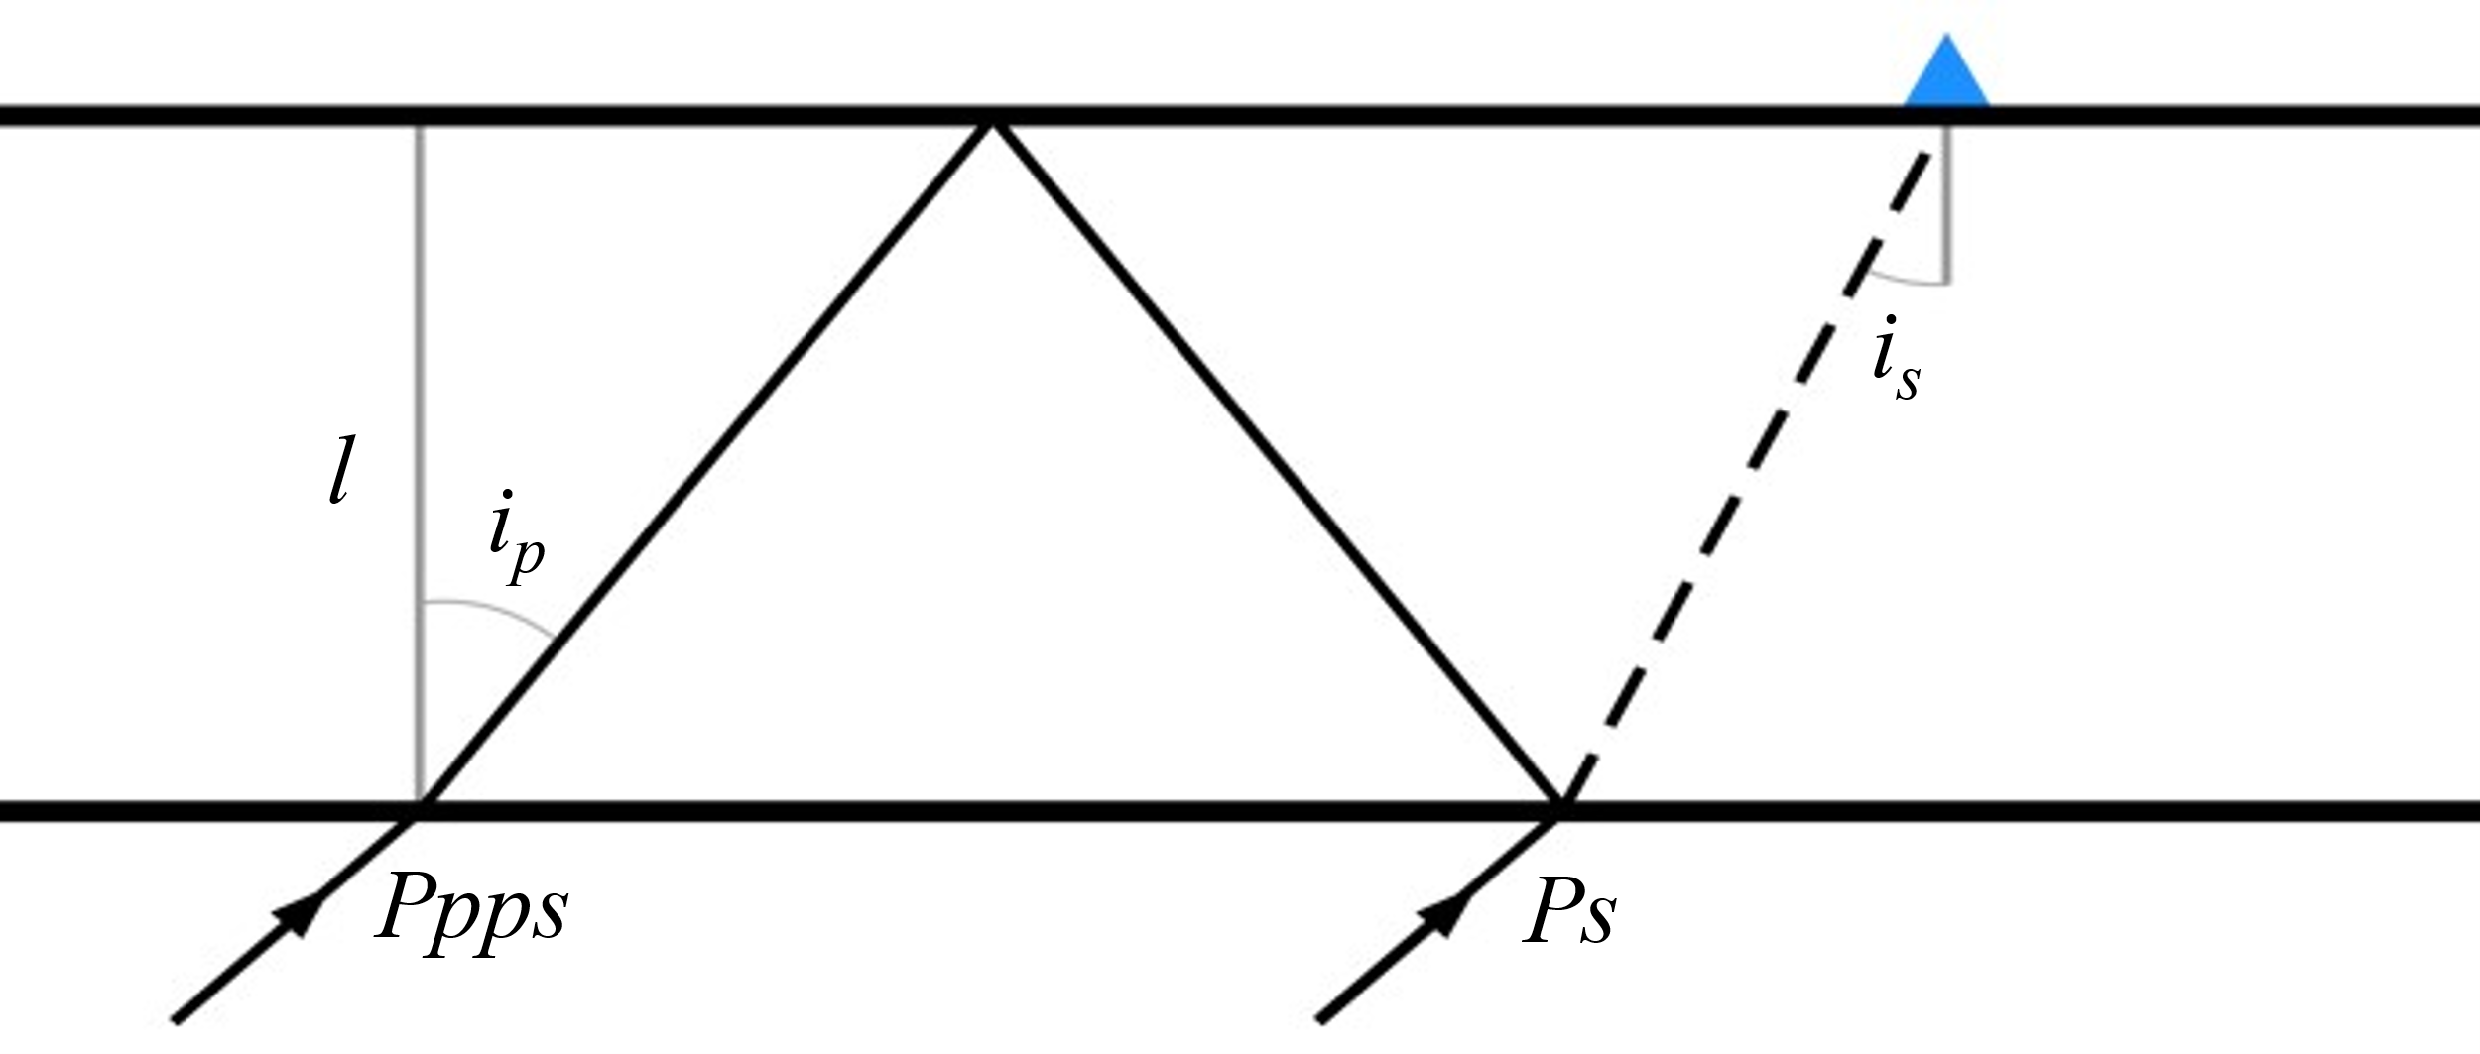

**Figure 1. Diagram of ray-paths of phases *Ps* and *Ppps* to a receiver above a single layer. Solid and dashed lines denote *P*- and *S*-wave segments. Upper- and lower-case letters denote wave type in the half-space and layer respectively.**

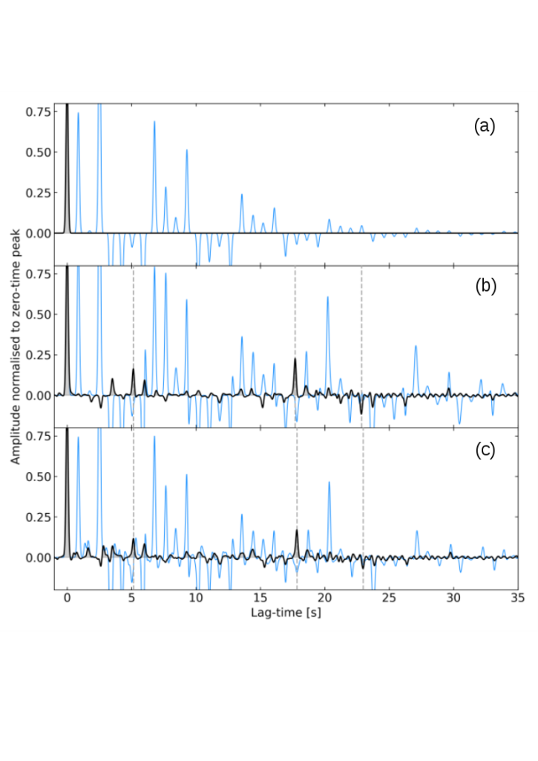

**Figure 2. Synthetic PRFs (blue) and filtered results (black). Dashed lines show ice-removed lag-times of Moho phases: *Ps*, *Ppps*, and *Ppss*. (a) Average CCD ice model PRF (blue), filtered into the desired zero-time peak (black); (b) Single layered average crust below ice; and (c) Multilayered crust below ice.**

|  |  |  |  |  |  |  |  |  |  |
| --- | --- | --- | --- | --- | --- | --- | --- | --- | --- |
| ***Station ID*** | ***Station name*** | ***Ice core***  **[km]** | ***Ice l* [km]** | ***% error*** | ***Ice vp* [km/s]** | ***Ice vs* [km/s]** | ***Ice vp/vs*** | ***Bedrock vs* [km/s]** | ***No. of PRFs*** |
| CCD | Concordia,  East Antarctica | 3.275 | 3.278 | 0.09 | 3.878 | 1.919 | 2.022 | 3.275 | 15 |
| BYRD | Mary Byrd Land,  West Antarctica | 2.164 | 2.138 | 1.2 | 3.831 | 1.79 | 2.143 | 2.875 | 5 |
| NEEM | Eemian,  Greenland | 2.461 | 2.475 | 0.57 | 3.85 | 1.829 | 2.107 | 3.04 | 6 |

**Table 1. Ice stations, average inversion results for ice parameters, bedrock *vs* estimate, and the number of PRFs processed in this project (all earthquakes were from the Fiji Islands region). Ice core measurements: CCD (Parrenin et al., 2007), BYRD (Bentley, 1972), and NEEM (Montagnat et al., 2014).**

**REFERENCES IN THE TEXT**

The referencing conventions should follow those used in the journal *Geophysics*. In the main text, where a reference appears as part of a sentence, it should show the authors’ names, followed by the year of publication in parentheses. Where the full reference is parenthesised, use a comma to separate the date. When reference is made in the text to work by three or more authors, only the first author’s name should be used, followed by “et al.”.Some hypothetical referencing examples follow.

Based on findings by Julià (2007), the *Ps* phase amplitude is controlled by the *vs* contrast. Aki and Richards (2002) provide more theoretical details. Ice-core measurements for station CCD are from Parrenin et al. (2007). The measured ice-phase lag-times can be matched to a synthetic ice-layer PRF created with the Thomson-Haskell matrix formalism (Thomson, 1950; Haskell, 1953). More detail on the construction of synthetic PRFs is given in Harpley (2020) and Harpley et al. (2021).

**CONCLUSIONS**

It is normal to have a final CONCLUSIONS section. (If the outcomes are less clear cut, you may prefer a DISCUSSION section.) This section might include such things as theoretical or practical implications of the results, anomalies in the work, and agreements or disagreements with previously published work. In a conference abstract it is generally acceptable to include some personal opinions or observations, but these must be relevant to, and supported by, the work presented.

**ACKNOWLEDGMENTS**

Acknowledgments are optional. Generally, people who have made significant technical contribution to the work would be co-authors. Other contributions and support from people and organisations can be acknowledged here.

**REFERENCES**

The reference list below corresponds to the example references used in this template. Various examples for journal articles, conference abstracts, books and theses have been included. All references in your text must be listed, but no others. To be of real value, authors should attempt to reference material that is readily accessible to the reader. References should be listed alphabetically by author. Do not abbreviate journal titles. Again the conventions generally follow *Geophysics.*

Aki, K., and Richards, P.G., 2002, Quantitative seismology: Second Edition, University Science Books.

Bentley, C.R., 1972, Seismic‐wave velocities in anisotropic ice: A comparison of measured and calculated values in and around the deep drill hole at Byrd Station, Antarctica: Journal of Geophysical Research, 77(23), 4406-4420.

Harpley, D., 2020, Crustal structure under Concordia, Antarctica from teleseismic P and S phases: B.Sc. Honours (Exploration Geophysics) Thesis, University of Queensland.

Harpley, D., Hearn, S., and Strong,S., 2021, Attenuation of ice-sheet reverberations in teleseismic P-wave receiver functions: Extended Abstracts, 3rd AEGC: Geosciences for a Sustainable World, Brisbane, Australia.

Haskell, N.A., 1953, The dispersion of surface waves on multilayered media: Bulletin of the Seismological Society of America, 43(1), 17-34.

Julià, J., 2007, Constraining velocity and density contrasts across the crust–mantle boundary with receiver function amplitudes: Geophysical Journal International, 171(1), 286-301.

Montagnat, M., Azuma, N., Dahl-Jensen, D., Eichletoolr, J., Fujita, S., Gillet-Chaulet, F., Kipfstuhl, S., Samyn, D., Svensson, A., and Weikusat, I., 2014, Fabric measurement along the NEEM ice core, Greenland, and comparison with GRIP and NGRIP ice cores: The Cryosphere Discuss, 8, 307-335.

Parrenin, F., Barnola, J.M., Beer, J., Blunier, T., Castellano, E., Chappellaz, J., Dreyfus, G., Fischer, H., Fujita, S., Jouzel, J., and Kawamura, K., 2007, The EDC3 chronology for the EPICA Dome C ice core: Climate of the Past, 3(3), 485-497.

Press, W.H., Flannery, B.P., Teukolsky, S.A., and Vetterling, W.T., 1992, Numerical recipes in Fortran77, 2nd edition - The art of scientific computing: Cambridge University Press.

Thomson, W.T., 1950, Transmission of elastic waves through a stratified solid medium: Journal of Applied Physics, 21, 89-93.